25 November 2025
Name: HAFSAT ANAS | Age: 20y | Sex: F | Ref No:0002
Clinical Details: USG Pelvic |  |  | US:02
OBSTETRIC ULTRASOUND
UTERUS: The uterus is gravid and shows multifetal intrauterine pregnancy. The amniotic fluid is adequate. Thick inter twin membrane seen (suggestive of MCDA twin pregnancy).

Twin 1:
PRESENTATION = BREECH
PLACENTA = ANTERIOR
GA = 34 weeks 01 day(s)
EDD = 06/01/2026(±2weeks)
EFW = 2.26Kg
GENDER = XY

Twin 2:
PRESENTATION = BREECH
PLACENTA = ANTERIOR
GA = 32 weeks 3 day(s)
EDD = 27/04/2024 (±2weeks)
EFW = 1.91Kg
GENDER = N/S (NOT SEEN)
CONCLUSION: Twin MCDA gestation AT 34 weeks 01 day(s).

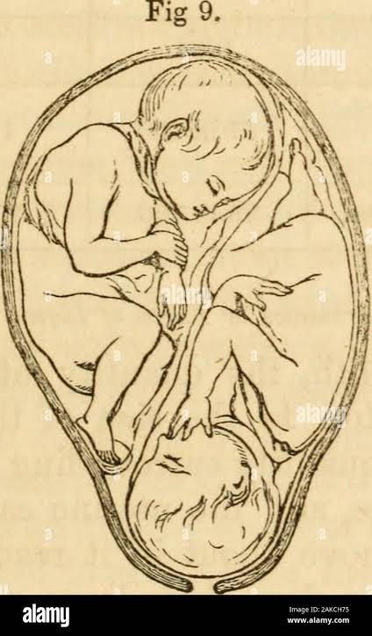

```Ultrasound Specialist

